Following are the various options to retreive the SCG Court software from Sourceforge. Note that in all of the below options, you can only update the latest version from the repository and cannot commit your versions into the repository.

Option 1: Using an svn client installed on your machine

- Install an svn client on your machine
- On Linux Machines, run the following comamd
  - svn checkout svn://svn.code.sf.net/p/generic-scg/code-0/GenericSCG – This will create a project under a 'GenericSCG' folder in your current directory.
- On Windows machines, right click on the directory in which you want to create the folder and click on SVNCheckout. In the resulting window that appears, specify

svn://svn.code.sf.net/p/generic-scg/code-0/GenericSCG

in the 'URL of repository' field

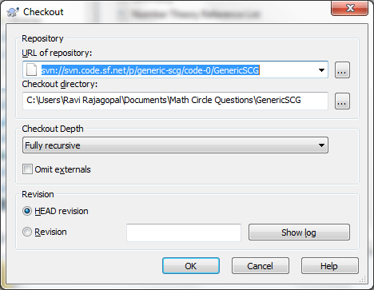
Once you have a local copy of the repository, you can use the command 'svn update' on linux machines or right click on the folder and click on svn update on windows machines to import the latest code from the repository.

Option 2: Using a subversion tool installed on Eclipse

Use the below set of steps to Install a subversion client that Eclipse supports. In the below set of screenshots, I have used the subversive tool. Further note that the below set of steps are based on the Galileo version of Eclipse. In case of a later version, you can use the Marketplace option to install the client. The sequence of steps are similar.

- Click on Help → Install New Software.
- If the site – http://download.eclipse.org/releases/galileo/ - is not already available, use the 'Add' button to add this site. Once this site is added and is selected, you should see options as in the screenshot below

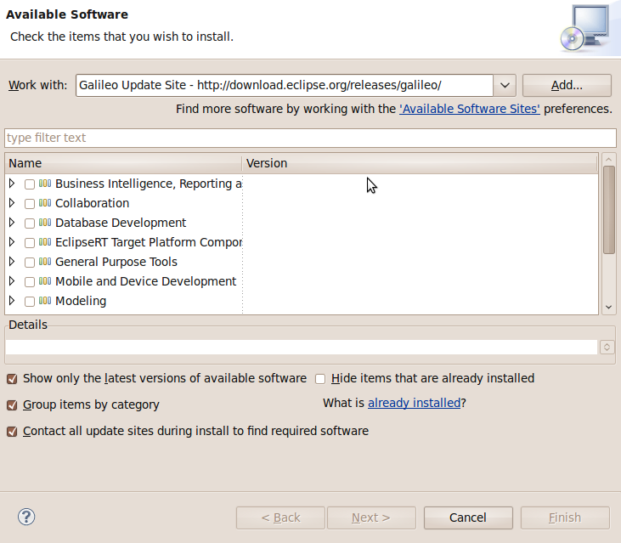

- Expand Collaboration and select the option 'Subversive SVN Team Provider (Incubation)' and click on 'Next'

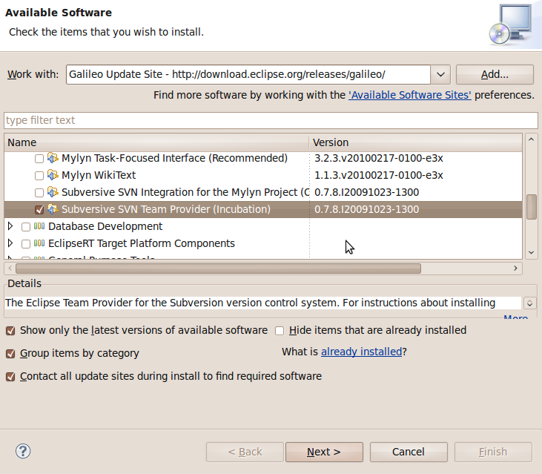
- Follow through the next sequence of windows including accepting the terms of the license agreement. Once this is installed, restart Eclipse SDK for the changes to take effect.
- Once Eclipse SDK is restarted, click on Window → Preferences

- Select Team → SVN

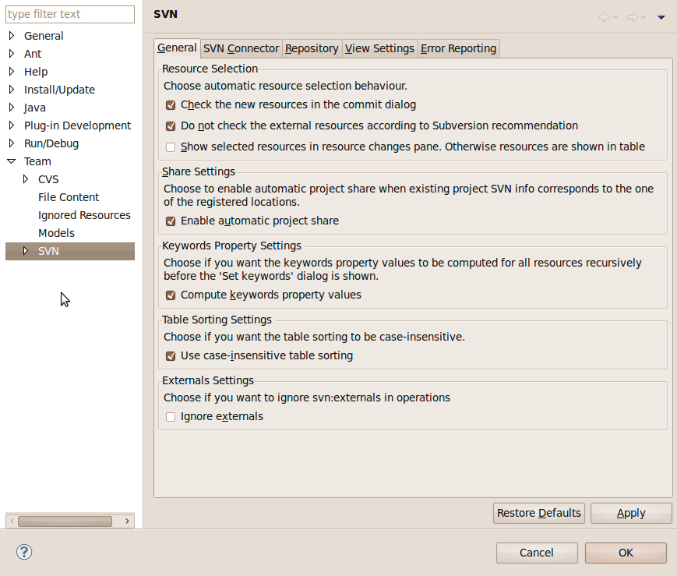

- A window should automatically open up giving options on the various connectors to be installed in order to use the subversive client.

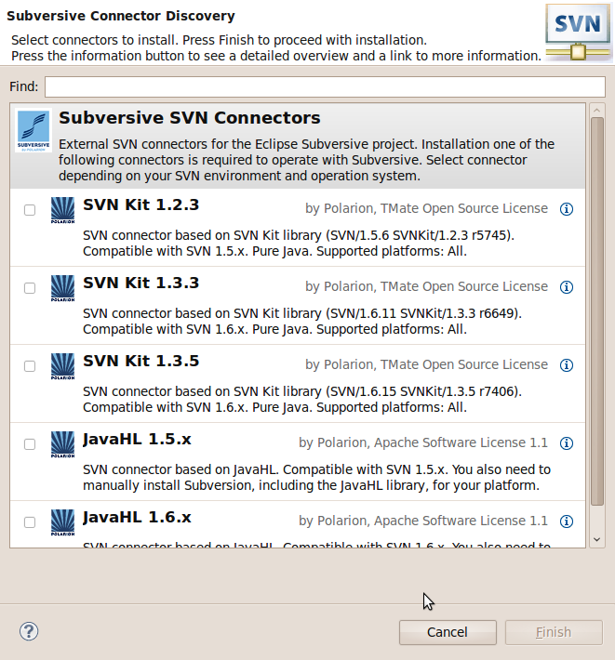
- Again follow through the next sequence of steps, including accepting the license agreement to complete installation.

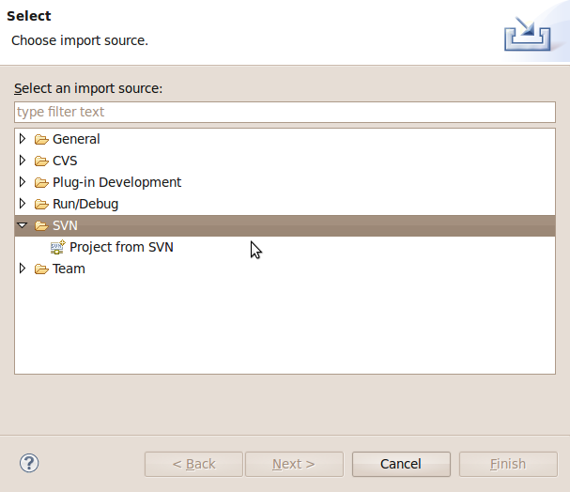
- Now that subversive and connectors have been installed, you can now use them to import code from svn. Click on File → Import and select SVN → Project from SVN as your import source.

- Specify the URL as svn://svn:code.sf.net/p/generic-scg/code-0/GenericSCG (Note that the below screenshot contains the URL at one level above what is required)

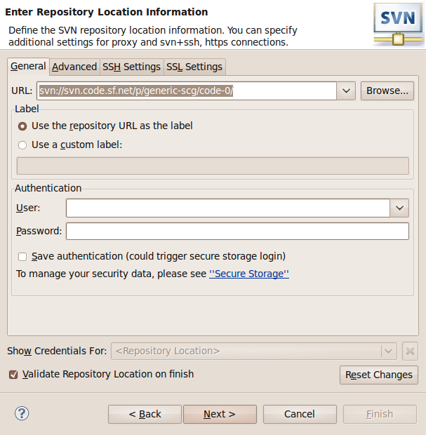

- Select the option 'Check out as a project with the name specified:'

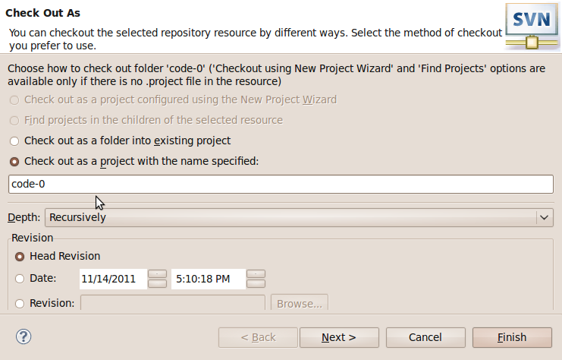
- Once the files are imported as a project, you can right click on the project, click on Team and use the following options to bring the latest code from sourceforge
    - Update – This does not overwrite any files that you have modified
    - Synchronize Repository – This overwrite files that you have modified.

If you need to browse through its code, please go to http://sourceforge.net/p/generic-scg/code-0
Further you can also use the link to raise a ticket if you have any issues with the software.

Steps to use Sourceforge's ticket system to report issues.

  - register for an sourceforge account
  - go to project's home page
  - click the “Tickets” tab
  - click “Create Ticket” in the side bar
  - input your issue in the next page and click “Save” in the end.

